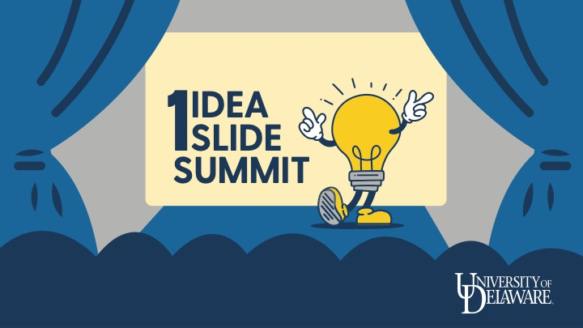

2023 One Idea, One Slide | Ideas and Pathways

Academic Programs
Several ideas contemplated creation of new undergraduate, graduate, and certificate programs. Other ideas contemplated the development of coursework or experiential learning opportunities that would benefit the development of academic programs. Each of these ideas has been advanced along the academic programs pathway. The Office of the Provost is developing a suite of resources and support for creating new academic programs, which will offer support to these submitters contemplating something similar.
- Academic Program in Health Wearables
- Aligning UD Resources for Health Informatics, Innovation and Entrepreneurship Education (HIIEE)
- Development of B.S. and M.S. programs in Renewable Energy
- Diving into History: Global Living and Learning Expeditions for Undergraduates
- Enhancing Pre-Medical Education: Creating a Center for Anatomy & Physiology Education (CAPE)
- Expanding interdisciplinary opportunities and identifying sustainable solutions to global environmental problems: linking experimental economics with science, policy, and engineering innovations
- Laboratory for a Just Green Transition
- PhD Program in Statistics and Data Science
- Program in Peace, Justice and Science Diplomacy (PJSD)
- SCUBA as a multidisciplinary tool to engage and excite students
- Sports Science & Analytics academic initiative
- Sustainability, Innovation, and Business Program
- UD Webb Farm Expansion

Coordination with Existing Groups and Efforts
Several ideas were connected in interesting ways to ongoing efforts within other units across the university. To maximize the ability to utilize these existing resources, and to understand where the synergies lie, each of these ideas has been advanced along the pathway of coordination with existing programs and efforts. Each presenter has been connected with individuals from units and programs to discuss their idea and see how it could be advanced.
- An Interdisciplinary, Grass-Roots Approach to Pandemic Preparedness
- Documenting and Evaluating Durable Skill Development in a First-Year Integrated Honors Introductory Biology/Chemistry Courses
- Ed-Led: An Educator-Led, Equity-Centered School Change Movement
- Elevate Student Employment to Improve Student Retention and Postgraduate Success
- Full Participation in Transformational High-Impact Practices
- Providing On-Site Social Worker to Meet Students' Diverse Needs
- Sustainability Enhancement and Educational Development (SEED) Program
- UD Center for Artificial Intelligence (AI)-enhanced Digital Twins
- UD International Arts & Humanities Collaboratory in Santiago and Valparaiso, Chile
- Victory Gardens to Provide Agency & Alleviate Climate Change
- Waste Upcycling with Insects for a more Sustainable UD

Research Opportunities
Several ideas were connected with opportunities that were focused on research efforts, such as the creation of core facilities, new centers and institutes, and faculty research projects. These ideas were advanced by the research opportunities pathway.
- Awesome Forests: Indigenous Epistemologies of the Landscape
- Center on dietary nanoplastics: A “One Health” perspective on emerging food contaminants
- Core Robotics Facilities
- Driving Biotech Advancements, Cultivating Social Impact
- Enhancing International and Cross-Cultural Implementation of an Early Parenting Program
- Enhancing Livability in Coastal Communities: Developing an Integrated Modeling Framework for Nuisance Flooding Prediction and Mitigation
- Go To High School and Graduate From College: The Educational Dilemmas of Black Males in Delaware and at UD
- Institutional Research Data Storage System
- Reducing global methane emissions using pyrogenic black carbon
- Simultaneous Mechanically Integrated Live Emulation Systems (SMILES) for Drug Testing
- Spatial Biology/Spatial Omics Research Core (SORC) at the University of Delaware
- The Relationship Between Body Image and Psychological Wellbeing and Its Influence on Health-Related Behavior in Young Adults
- UD Center for Translational Synthetic Biology
- Using EEG to pinpoint a child language impairment

Seed Funding
Several ideas were thought to be at a point at which internal seed funding and supportive resources can make them transformative and teams have been built around these proposals to develop and execute on their pilot projects.
- BRACE for Change: Building Resilience through Applied Civil | Coastal | Collaborative
- Center for Sustainable Island Futures
- DelaWear
- Energizing Coastal Resilience – Research, Education, and Impact: Planning Grant
- FinTech Innovation: Privacy-Preserving Credit Risk Prediction with Alternative Data
- Leadership Hub
- UD Game Hub
- Unidel Institute for Creative Career Pathways

Coordinated University Request for External Funding
Several projects were identified as ready for coordination and development for submission to external foundations. Facilitators have been assigned to project teams to craft these proposals for this fall.
- A Comprehensive Approach to Recruiting, Retaining and Welcoming Students of Color into UD’s Teacher Education Programs
- A University Center for Environmental Justice and Ecological Regeneration
- Acquisition of an Aberration-Corrected Scanning Transmission Electron Microscope (AC-STEM) for the Microscopy Laboratory (CAMM) in the University of Delaware Patrick Harker ISE-Lab
- Adapted Fitness Equipment
- AI-Enhanced Learning: A New Frontier for Foundational Courses
- Center for Sustainable Mobility (CSM)
- CHAT2AI: Center for Human-Robot Trustworthy Teaming in the Era of Artificial Intelligence
- Creating the “Sustainable Food Solutions Delmarva” Initiative
- DELPHI: Establishing a Delaware Public Humanities Institute
- DURABL – the Delaware Urban Analytics and Public Affairs Program
- Environmental Legacies, Ecosystem Restoration, & Healthy Communities: Understanding landuse legacies and revitalizing our landscapes for more diverse, resilient, and equitable ecosystems
- Equity in Action
- Expanding Graduate Student Contributions in Diversity, Equity, and Inclusion
- Global Migration and Forced Displacement Hub
- Graduate Success Academy (GSA)
- Investing in the Blue Economy by Creating a Fisheries & Aquaculture Innovation Center (FAIC)
- Office of National Fellowships: Showcasing Academic Excellence at UD
- Reducing Student Costs Through Open and Affordable Materials
- Scholarship Opportunity for Students of Color to Pursue Education at University of Delaware
- South Campus Entry Plaza and Garden
- State-of-the-Art Marine Science Teaching Lab on the Lewes Campus
- Strategic Three-Year Support for The University of Delaware Teacher Residency Program Graduates
- Summer Mathematics Camp for high school students
- UD Study AiDE: Building and Training an Internal AI Model
- Upgrade of a 600 MHz NMR Spectrometer Console

